

**Computer Networks Lab 01**

**21K-3153c**

# Tasks

(Attach screenshot of command prompt/terminal where you are using it.)

1. Find the IP address of the computer you are currently using.

Command: ipconfig

IP Address: 172,16.30.34

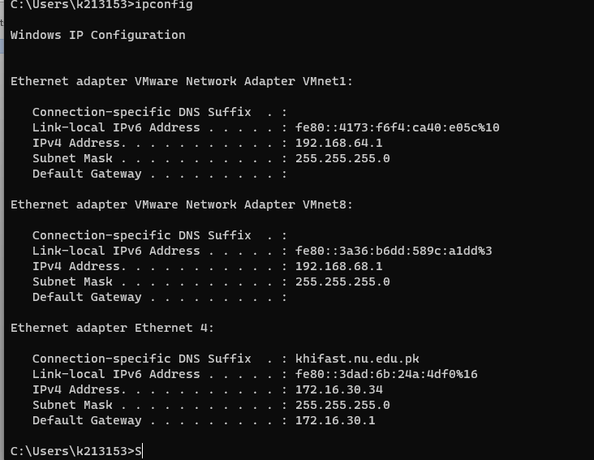

1. Find the IP address of the computer you are currently using, plus MAC address, the gateway, plus whether DHCP is turned on.

Command: ipconfig/all

IP Address: 172.16.30.34 Gateway: 172.16.30.1 DHCP: Yes

MAC Address: 74-86-E2-3C-5C-18

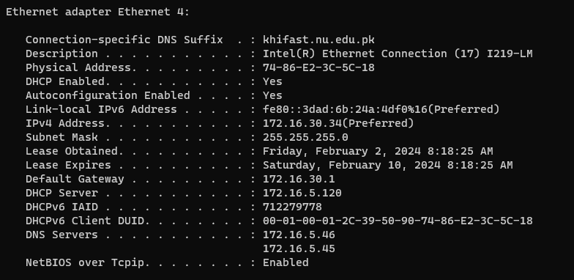

1. Display the host name of the computer.

Command: hostname

IP Address: Lab12PC38

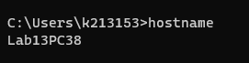

1. Check for basic IP connectivity between two computers by name and IP address. How can basic IP connectivity be checked? What are the reasons why there is no connectivity?

Command: ping ipaddress

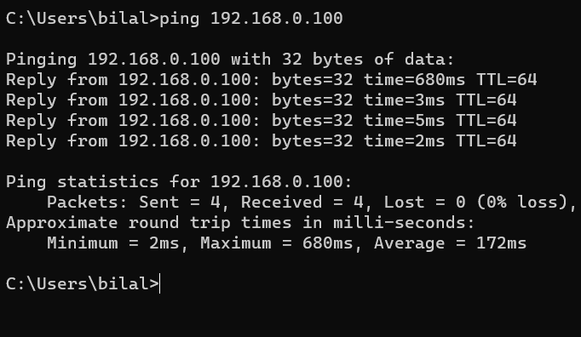

Reason: The device I am pinging could be offline or not connected to the network

1. Find out which ports on your host are connected to applications. Connect the browser to some external web page before running the appropriate command.

Command: netstat -an | find “ESTABLISHED”

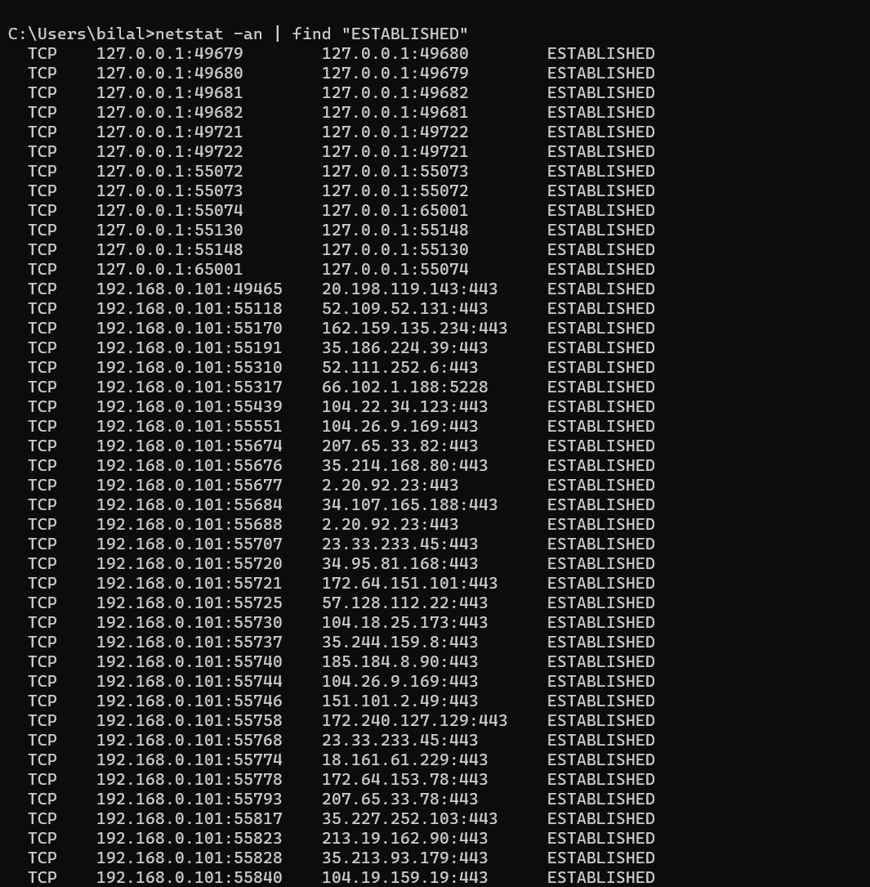

1. Find the path of routers to [www.google.com.What](http://www.google.com.What/) is its IP address? How many hops involved in the path?

Command: tracert [www.google.com](http://www.google.com)

Reason: 13 hops. IP address is : 142.250.181.4

1. A ping to 192.168.0.2 works but a ping to the machine’s name “blue machine” fails. What could be wrong?

Reason: Either the machine name “blue machine” is not correctly registered in the DNS or the name is spelled wrong.

1. Which type of cable will you use to connect in a normal home installation?

Answer:

Straight cables will be used to connected different types of devices such as connecting a computer to a switch’s normal port or connecting a computer to a cable/DSL modem’s LAN port.

Crossover cables will be used to connect the same type of devices such as connecting 2 computers with each other or connecting 2 switches with each other by using their normal ports.

An RJ45 connector is typically used to connect computers in LAN configurations. Two wiring schemes–T568A and T568B–are used.

1. Can you connect a Switch to another Switch or a router to a PC using a straight- through cable? Explain your answer.

Answer: Normally, no. To connect devices of the same type, such as switches using normal ports, a crossover cable would have to be used.

However, if there is auto MDI/MDI-X feature support on the switch, hub, network card or other network devices, you don’t have to use crossover cable in the situation which is mentioned above. This is because crossover function would be enabled automatically when it’s needed.

1. Write a brief report on your home network or any organizational network including topology, 1 page max).

Answer: My home network has 2 disconnected star topologies since my home has 2 routers.

In the first room, all devices are connected to the first router, including laptops and phones.

In the second room, all devices are connected to the second router, which includes laptops, phones and other accessories.

No device in my home uses ethernet.